**DAILY ONLINE ACTIVITIES SUMMARY**

|  |  |  |  |  |  |  |  |
| --- | --- | --- | --- | --- | --- | --- | --- |
| **Date:** | **01-06-2020** | | | | **Name:** | **Varsha H Shetty** | |
| **Sem & Sec** | **8th sem B sec** | | | | **USN:** | **4AL16CS117** | |
| **Online Test Summary** | | | | | | | |
| **Subject** | | **SMS** | | | | | |
| **Max. Marks** | | **60** | | **Score** | | **60** | |
| **Certification Course Summary** | | | | | | | |
| **Course** | **Java course** | | | | | | |
| **Certificate Provider** | | | **Great learning website** | **Duration** | | | **60 minutes** |
| **Coding Challenges** | | | | | | | |
| **Problem Statement-** : C program to print right angled triangle numbers star pattern | | | | | | | |
| **Status: completed** | | | | | | | |
| **Uploaded the report in Github** | | | | **yes** | | | |
| **If yes Repository name** | | | | **Varsha-Shetty** | | | |
| **Uploaded the report in slack** | | | | **yes** | | | |

Online Test Details: (Attach the snapshot and briefly write the report for the same)

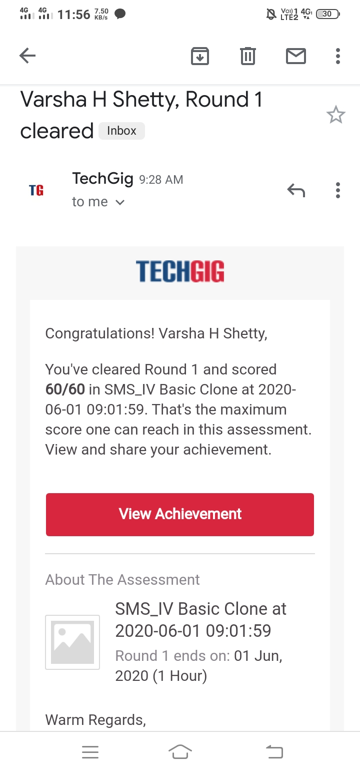

Certification Course Details:

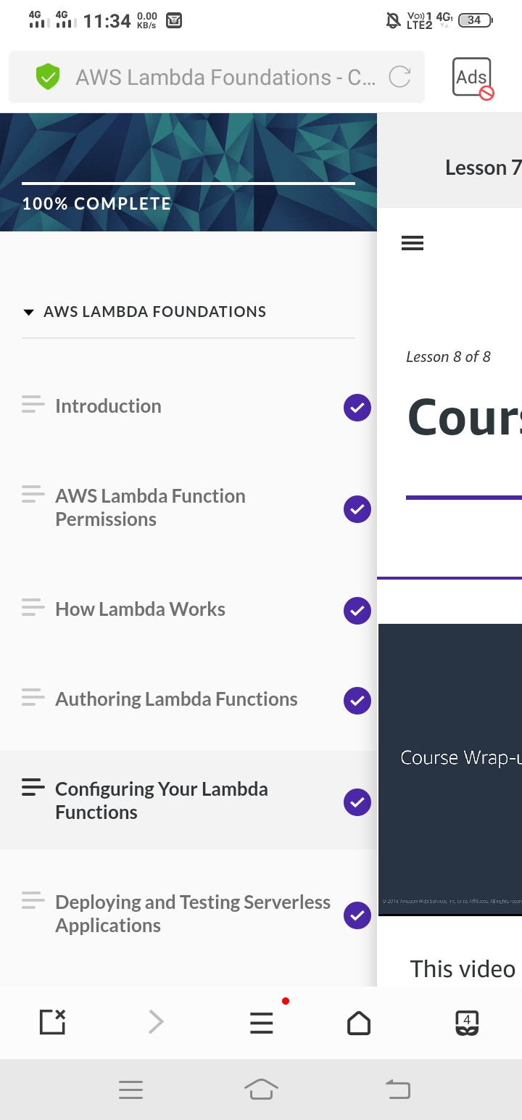

Coding Challenges Details: (Attach the snapshot and briefly write the report for the same)

Coding was given and it was uploaded for github and slack

**C program to print right angled triangle numbers star pattern**

int main()

{

int Rows, i, j;

printf("Please Enter the Number of Rows: ");

scanf("%d", &Rows);

printf("\n Printing Right Angled Triangle \n \n");

for ( i = 1 ; i <= Rows; i++ )

{

for ( j = 1 ; j <= i; j++ )

{

printf("* ");

}

printf("\n");

}

return 0;

}

int main()

{

int Rows, i, j;

printf("Please Enter the Number of Rows: ");

scanf("%d", &Rows);

printf("\nPrinting Right Angled Triangle \n \n");

for ( i = 1 ; i <= Rows; i++ )

{

for ( j = 1 ; j <= i; j++ )

{

printf("* ");

}

printf("\n");

}

return 0;

}